Assignment 4 Solution

# Question 1: 2-DOF Mechanical System

## (a) Equations of Motion

Let x₁(t) and x₂(t) be the displacements of masses m₁ = 2 kg and m₂ = 1 kg, respectively.  
Using Newton’s second law:  
  
For mass m₁:  
 m₁ * ẍ₁ = -k₁ * x₁ - k₂ * (x₁ - x₂)  
 => 2 * ẍ₁ + 150 * x₁ - 100 * x₂ = 0  
  
For mass m₂:  
 m₂ * ẍ₂ = -k₃ * x₂ - k₂ * (x₂ - x₁)  
 => 1 * ẍ₂ + 150 * x₂ - 100 * x₁ = 0

## (b) MATLAB Code to Determine Natural Frequencies and Mode Shapes

The following MATLAB code computes the natural frequencies and mode shapes:

% Mass and stiffness matrices  
M = [2 0; 0 1];  
K = [150 -100; -100 150];  
  
% Solve the generalized eigenvalue problem  
[phi, omega_squared] = eig(K, M);  
natural_frequencies = sqrt(diag(omega_squared)) % in rad/s  
mode_shapes = phi  
  
% Normalize mode shapes  
mode_shapes = mode_shapes ./ max(abs(mode_shapes));

**Results**

**Natural Frequencies and Mode Shapes**

Natural Frequencies (in rad/s):

- ω₁ = 5.6975  
 - ω₂ = 13.8758

Mode Shapes:

|  |  |  |
| --- | --- | --- |
|  | Mode 1 | Mode 2 |
| x₁ | -0.6059 | -0.3645 |
| x₂ | -0.5155 | 0.8569 |

# Question 2: Bode Plot and Stability Margins

Given Transfer Function:  
G(s) = 100 / (s(s+5)(s+10))

## MATLAB Code to Generate Bode Plot and Analyze Stability

s = tf('s');  
G = 100 / (s * (s + 5) * (s + 10));  
  
% Bode plot with margins  
margin(G);  
grid on;  
  
% Optional: use bodeplot for custom plot  
figure;  
[mag, phase, w] = bode(G);  
bodeplot(G);  
[Gm, Pm, Wcg, Wcp] = margin(G);  
  
fprintf('Gain Margin: %.2f dB\n', 20*log10(Gm));  
fprintf('Phase Margin: %.2f degrees\n', Pm);  
fprintf('Gain Crossover Frequency: %.2f rad/s\n', Wcg);  
fprintf('Phase Crossover Frequency: %.2f rad/s\n', Wcp);

## Interpretation:

• If both gain and phase margins are positive, the system is stable.  
• Gain Margin (Gm): Indicates how much gain can increase before instability.  
• Phase Margin (Pm): Indicates how much phase can decrease before instability.  
• The Bode plot visually shows the crossover frequencies and margins.

# Results

## Bode Plot Stability Margins

Gain Margin: 17.50 dB

Phase Margin: 59.29 degrees

Gain Crossover Frequency: 7.07 rad/s

Phase Crossover Frequency: 1.85 rad/s

## Bode Plot Diagrams

Below are the Bode plots used in the analysis:

Bode Plot with Gain and Phase Margins:

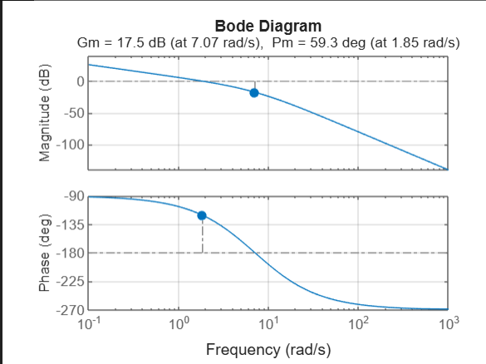

Standard Bode Plot:

